Year 5 Immersion Day

Last Friday, Year 5 enjoyed their immersion into Ancient Greece. We started by looking at the Greek alphabet and writing our names in Greek. We then found out a little bit about the Ancient Greek Olympic games and enjoyed some of the sports they practiced in our own PE lesson. We looked at how the Greeks used pottery and designed and made our own Greek pots and then had a Greek food taster session - thinking about the geography of Greece and how that impacts on the traditional Greek diet. All in all, a fun day was had.

Issue number: 17 Friday 2nd February 2024

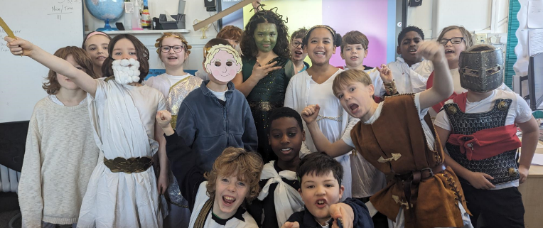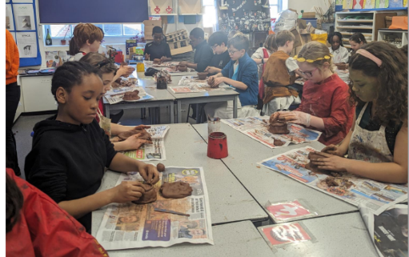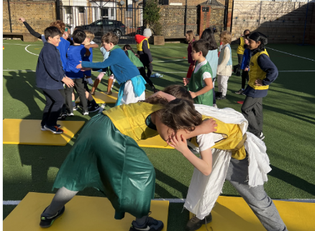

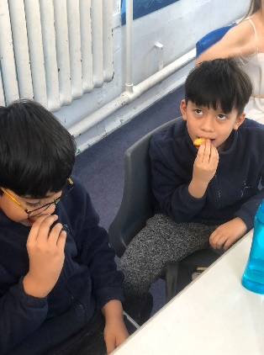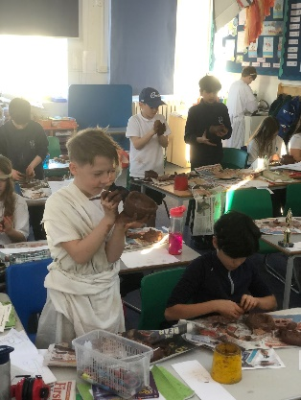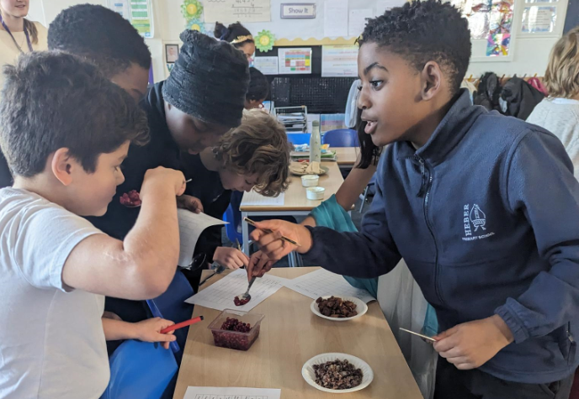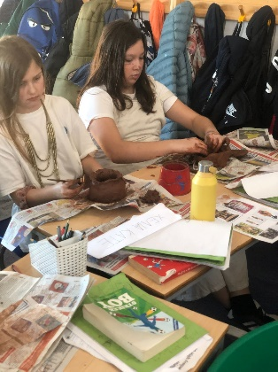

Heber Heroes!

Guess what happened on Friday, the 26th January? Every child in Year 6, and some from Year 5, faced off against the strong teams over at Alleyn’s in a football showdown that had the whole neighbourhood buzzing!

Six teams - three boys' squads, and three girls' squads, all geared up and ready to rumble. And guess what? Our Boys A team didn't just win, they dominated. Crushing Alleyn’s with a score of 6-2! Meanwhile, our Boys B team held their ground and walked away with a well-earned draw. Talk about showing them how it's done!

But hold onto your hats, folks, because our girls were in on the action too! They snagged two victories and fought hard in their other match. It's all about that Heber spirit!

Alleyn’s might have all the grass pitches and many full-time sports teachers, but did they see this coming? Probably not!

Heber's not just in the game, we're owning it! This is just the beginning. Watch out world, because our champions are on the rise! Go Heber, go! (Need to calm down...you are getting a bit over-excited – Editor)

Stars of the Week

Congratulations to the following children who were chosen as the Star of the Week this week:

Reception – (RC) and (RE)

Year 1 – (1DJ) and (1H)

Year 2 – (2L) and (2B)

Year 3 – (3LE) and (3C)

Year 4 – (4W) and (4P)

Year 5 – (5S) and (5A)

Year 6 – (6F) and (6K)

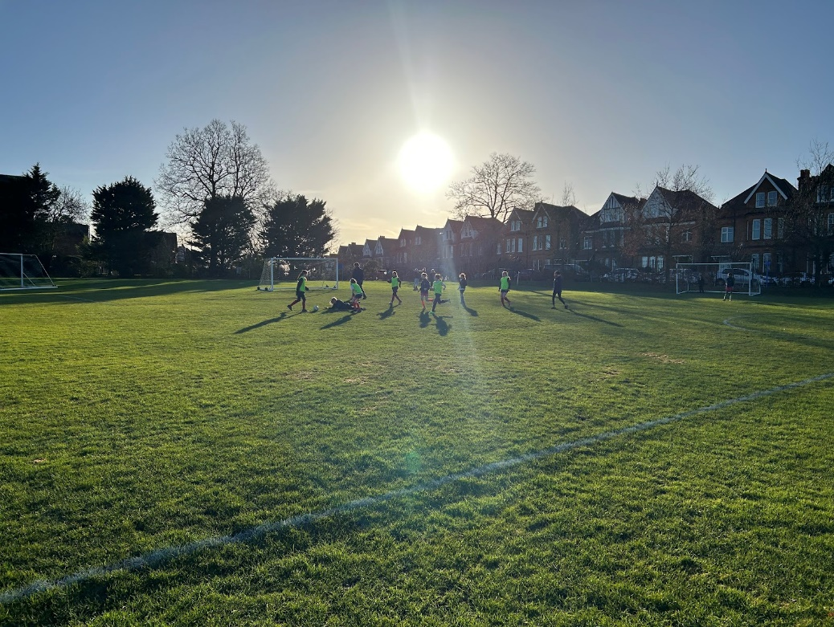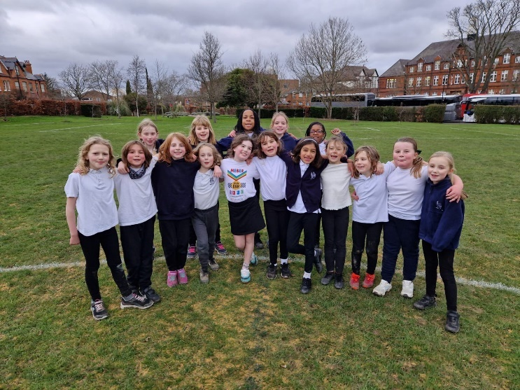

Heber Takes on Alleyn’s: David vs. Goliath Showdown!

Last week, Heber's sporting stars stepped onto the field with grit and determination, ready to take on the challenge presented by our neighbours at Alleyn’s. Over three action-packed afternoons, more than 120 enthusiastic children from Years 3 to 6 showcased their football prowess in a series of exhilarating matches.

In a true David versus Goliath fashion, our Heber teams proved their mettle, facing off against a formidable opponent. With 14 teams in the mix, the atmosphere crackled with anticipation as our young athletes displayed exceptional skill and teamwork.

Highlighting the triumphs of the day, our Year 6 boys, Year 4 girls, and Year 3 boys emerged victorious, defeating Alleyns' 'A' teams with flair and determination. The scoreboard reflected our resilience, boasting 7 wins, 2 draws, and 6 valiant losses.

The spirit of sportsmanship and camaraderie shone brightly throughout the event, with each player giving their all on the pitch. As the dust settles, we eagerly await the next chapter of this thrilling rivalry, with our Year 5s gearing up for their turn after the half-term break.

Congratulations to all our Heber heroes for their outstanding performance and unwavering determination. It is so lovely to see all the children at Heber keen to represent the school.

Stars of the Week

Congratulations to the following children who were chosen as the Star of the Week for demonstrating our school values this week:

RH Max RP Luca

1C Yusuf 1V Hollie

2H Kadri 2JP Aalia

3N Teddy 3W Arthur

4LC Davi 4S Hugo

5G Ruby 5K Matilda

6A Maria 6F Jayceon

Academic Excellence Awards

This week in our Merit Assembly we celebrated the successes of a child from each class, who excelled in their learning and produced some outstanding work. Well done to the following children:

RH Thea RP Xanthe

1C Arty 1V Lucy

2H Emmanuella 2JP Evelyn

3N Julia 3W Samuel, Kaya

4LC Gia 4S Carney

5G Arthur 5K Duke

6A Ridwan 6F Emily

Reception Space Exhibition

Wow, what an incredible display of the children’s work we had this week in Reception’s Space Exhibition. It was such a joy to see the children showing off the outcomes of their topic work to their parents. Excitement levels were very high!

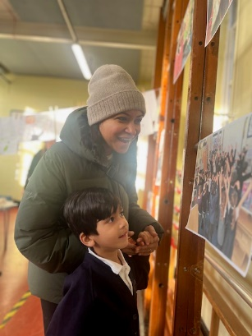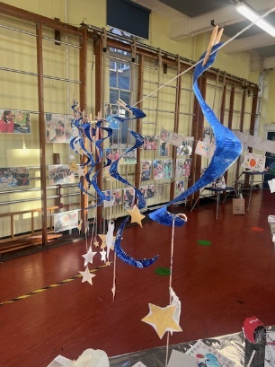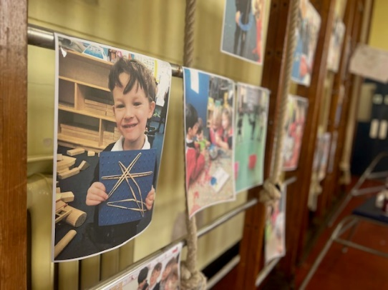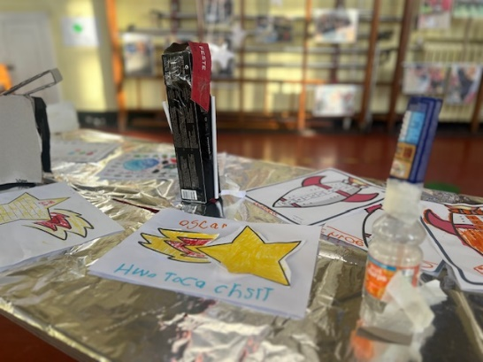

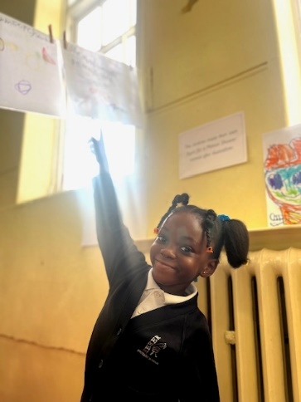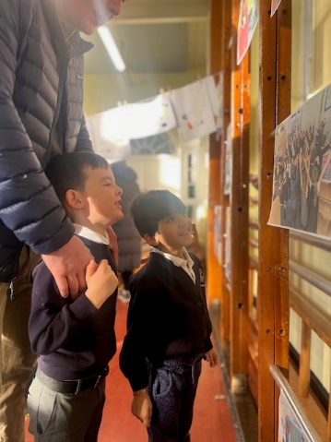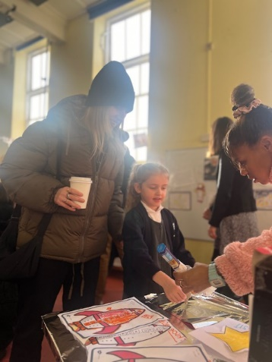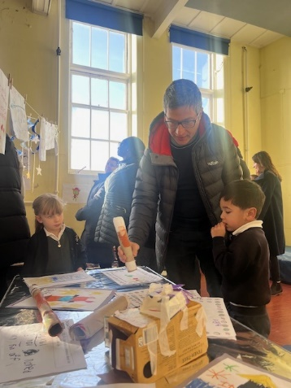

Music Stars

In music this week, Year 1 created their own melodies using short and long sounds and then performed them to the class. Year 2 had the opportunity to conduct the class, showing them whether they wanted them to play loudly or softly and quickly or slowly.

This term, KS2 are all starting to learn an instrument. Year Three have music every Thursday, and have now learned B, A and G on the recorder. They played a song using the notes B and A, along with a backing track. Year 4 continued to perfect their open and bass tones on the Djembe. They also learned how to perform a controlled drum roll and created their own call and response rhythms. Year 5 can now all play a G major scale on the steel pan and have nearly learned the whole chorus to ‘Oh When the Saints’. Year 6 learned the A minor chord and had a go at playing a strumming pattern on the Ukulele.

Each week Miss Grace chooses two music stars from each class. Well done to all the music stars this week and last week!

1C – Bea, Rafferty, Olivia, Caleb 1V – Meriel, Hollie, Alice, Aidan 2JP – Marlon, Mae, Priscilla, Theo

2H – Sofia C, Alex, Mya, Freddie 3N – Finn, Reuben, Molly 3W – Samuel, Safeeya, Luna, Dylan

4LC – Arthur, Emily, Eve S, Julian 4S – Lila, Carney, Arthur, Keira 5K – Georgia, Thomas, Amiya, Joseph

5G – George, Felix, Louis, Ruby

*This term, Year 6 are competing in teams to win house points, so there won't be any music stars.

This Week in Art

In Art this week, we are letting you have a sneak peek at our 'work in progress' Mother's Day Portrait competition entries.

This is a local competition run by 'Dulwich Trader, ed & Tomlinsons’.

Any winners will have their work displayed in the store: ed (41 North Cross Rd, SE22 9ET) from Friday 23rd February to Monday 11th March.

All entries will be returned by week commencing Monday 26th February so that children can give pictures to their mothers / special persons for Mothers’ Day.

If your child would still like to bring in a photograph of their mother to help with their entry, they can do so next week (this will be the final week we are working on them.)

Thank you

Mrs Coulson

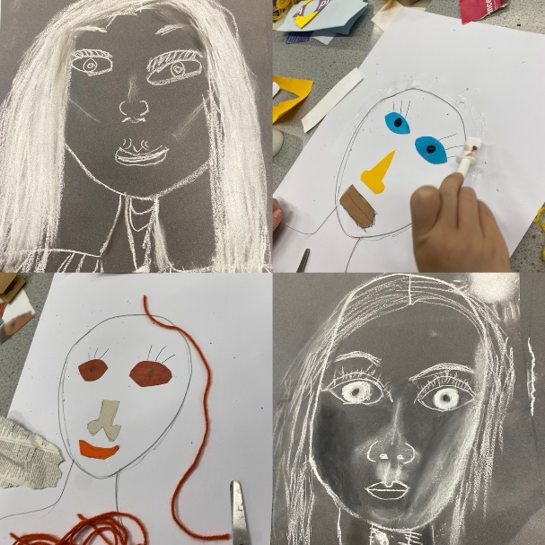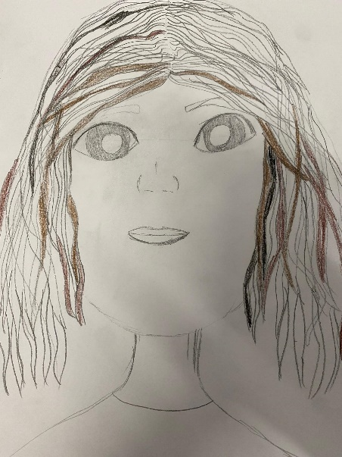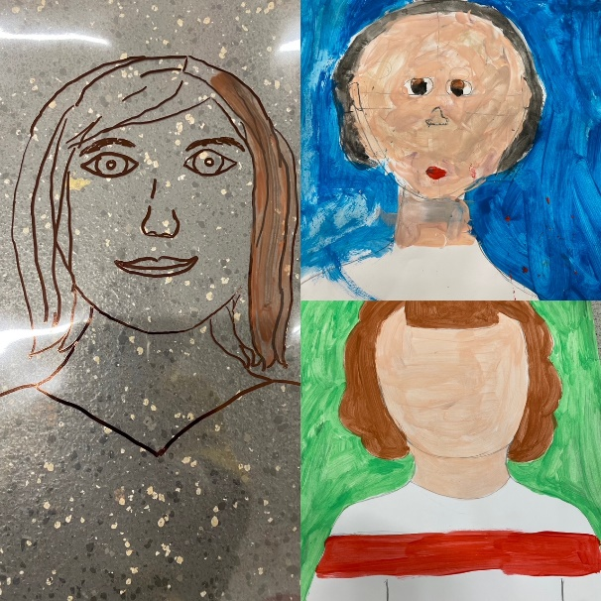

|  |  |  |  |  |
| --- | --- | --- | --- | --- |
| **House Points** | **Rigal** | **Mycroft** | **Valdez** | **Ndume** |
|  | **https://lh6.googleusercontent.com/Z6319_xVgluTFnng-BJv_e8dIWyPQg6AKyZihbtb8ci9eD-nQWBw8IUmWU7mPEgiZCjUg0mdLkp8o6GmG6UpTPJhGQZvnBsqmMNFnZ1F1HKawCl3vv8AYAyuWa1aMUxH1f9HKs6w9VIPJggCb2ycujc** | **https://lh6.googleusercontent.com/1s_oRUQqqOh9bhOeGMN-Oq2sRL2h5jdB8TqK2pVAFj6XomDlFICLhVMMuBrMyYoJaHm32NmBq9kzP4TyNiGkpSIwbRGO6jx9uefvVc834e9NjUwFbgGjUaauPwzxQbSLaFZK3UdUjIbA94XGmLamLss** | **https://lh3.googleusercontent.com/h_6tsMZheKPvcy4FLb5X6c0txPsx9gP2HynCWlJ3G1KLi_t02QHI1ULPlZrOY-Lj09TTsGSz4lFGEwmBPdwnnr3VmnSdjMGGwG4x5v0HOEY6hjB3HkfHmf7bmk3PkBWJ-yCa8R3CoS-s43crvYcd9tI** | **https://lh3.googleusercontent.com/BRSrKDwHqUeWXlejE4nGUuBX0KuKOJLPnQi9voKSqP9NArlt1MoseKK8XYnlbYrrJipFps0V2ScnLy4frq2obifSp2ynip6dX1U_p140_8odgboCnZfuwfEEMvj17aSHTsN8ZIXkaehefdLZUUmdFTQ** |
| **This Week** | 574 | 590 | 584 | 587 |
| **Total** | 1680 | 1680 | 1674 | 1683 |

Ros Atkins Visit

This week, Years 5 and 6 were very fortunate to have a special visitor in assembly. Ros Atkins, an ex-Heber parent and journalist, has kindly returned to Heber to lead an assembly for the children. Ros’ assemblies are always highly engaging and provide the unique opportunity to not only broaden the children’s perspectives, but also enhance their understanding of the world around them. On this visit, Ros spoke to the children about his work and amongst other things, the importance of questioning the source of information that we hear. He also engaged the children with a great activity that helped them to see the importance of listening carefully to information and asking thoughtful questions. See Molly and Matilda’s write up below for more info!

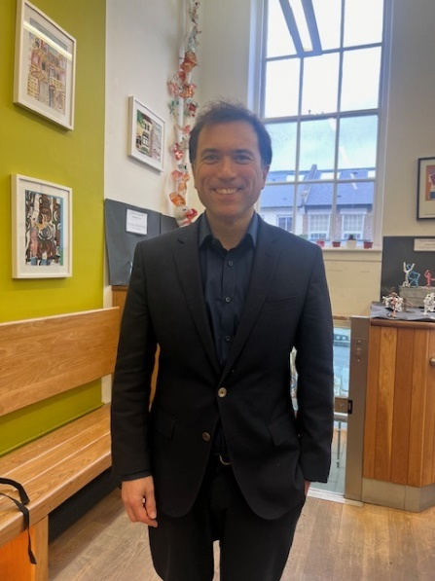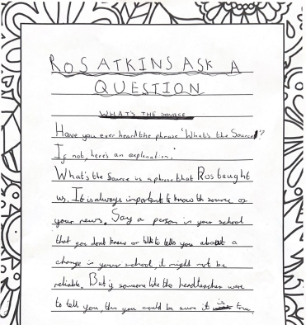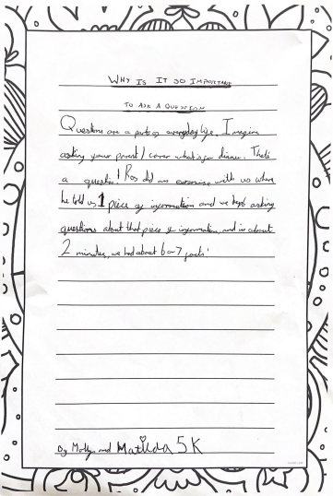

A Letter to the PM

Inspired by the letters that her class wrote to the Prime Minister in class recently, Sienna in 2H decided to write her own at home. She very proudly showed her letter to the class this week. She said that she already had two pen friends, so she thought she’d try to make a third!

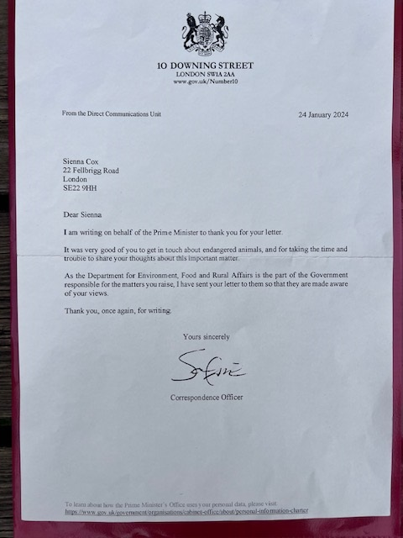

February

|  |  |
| --- | --- |
| Monday 5th – Friday 9th | Children’s Mental Health Week |
| Monday 5th | Years 3 – 6 Resilience Workshops run by Groundwork |
| Tuesday 6th | 3W – Guildhall Art Gallery & London’s Roman Amphitheatre  Class Assembly – 3N (9:15am) |
| Thursday 8th | 2JP – Monument visit |
| **Monday 12th – Friday 16th**  **Half Term Holiday** | |
| Monday 19th | 3W – Dance workshop at Alleyn’s  Away match – Year 3 football, boys tournament vs Alleyn’s (1:00pm-4:00pm) |
| Tuesday 20th | Away match – Year 4 football, boys tournament vs Alleyn’s (1:00pm-4:00pm) |
| Thursday 22nd | Away match – Year 5 football, boys tournament vs Alleyn’s (1:00pm-4:00pm) |
| Friday 23rd | Get Rid of and Donate collection (3:45pm)  Away match – Year 6 football, boys tournament vs Alleyn’s (1:00pm-4:00pm) |
| Tuesday 27th | Class Assembly – 6A (9:15am)  Away match – Year 5 football, girls tournament vs Alleyn’s (1:00pm-4:00pm) |
| Wednesday 28th | Class Assembly – 6F (9:15am) |
| Thursday 29th | 2H – Guildhall and Monument visit |
| March   |  |  | | --- | --- | | Monday 4th – Friday 8th | Book Week | | Tuesday 5th | Class Assembly – 5G (9:15am) | | Wednesday 6th | Book Week dress up day – theme tbc | | Thursday 7th | World Book Day  1C visiting the Postal Museum | | Tuesday 12th | Class Assembly – 5K (9:15am) | | Friday 15th | School discos – after school | | Tuesday 19th | Class Assembly – 4S (9:15am)  Year 5 – Junior Road Watch  Parents Evening | | Thursday 21st | 1V visiting the Postal Museum  Parents Evening | | Friday 22nd | Eco-Committee pre-loved clothes swap (3:30pm) | | Tuesday 26th | Class Assembly – 3W (9:15am) | | Wednesday 27th | Last day of enrichment clubs | | Thursday 28th | Last day of term – school finishes at 2:00pm | |  |  | | |